**Authors**

Jiayi Shen

Xiaoyu Yang

Yaoyuan Gan

# Introduction

Pokemon, as one of the most significant media franchises in the world, has captured the hearts and minds of millions of people globally. Spanning various platforms such as TV shows, video games, and manga, the phenomenon has generated an immense and dedicated fanbase. A key aspect contributing to the allure of the franchise lies in the diverse range of Pokemon, each with its unique forms and abilities. For many, the exhilaration of encountering and capturing new Pokemons in games constitutes an irreplaceable part of their childhood memories.

Despite the release of nine generations of Pokemon since 1996 and the existence of over 1000 different species, the insatiable appetite for more imaginative creatures among Pokemon enthusiasts shows no signs of abating. As a testament to this unwavering passion, the internet is replete with non-profit fan-made Pokemon games and creatively designed Fakemon. Although the enthusiasm for discovering new Pokemons remains high, there are inherent limitations to human creativity and Game Freak's capacity to generate new creatures.

Recognizing this challenge, our research endeavors to leverage the power of advanced machine-learning techniques to augment the process of creating new Pokemon. Specifically, we propose utilizing Generative Adversarial Networks (GANs) to develop an innovative Fakemon generator. This novel approach aims to address the limitations of human imagination while satisfying the ever-growing curiosity of Pokemon fans around the world. Ultimately, we seek to revolutionize the Pokemon universe by providing a robust and continuous pipeline of unique and captivating Fakemons that can fuel future generations of games and media, keeping the franchise vibrant and engaging for years to come.

# Methodology

Generative Adversarial Networks (GANs) include two Neural networks (NN). The first NN - generator (G) - generates fake images from a random noisy Guassian vector; The second NN - Discriminator (D) - judges the fake and true images to figure out the probability of real. Two NNs compete with each other: G tries to fool D by learning the data distribution from real images, and generating images from that distribution; meanwhile, D tries to figure out the difference between real and fake images.

Deep Convolutional GANs (DCGANs) published in 2015, introduced several convolutional layers without max pooling and fully connected layers into G and D, which significantly improved the quality of images (CITATION). Even though conventional layers improve the capacity of the generator to learn data distribution from training data, training DCGANs is still challenged.

As a result, a well pre-train Variational Auto-encoder (VAE) with convolutional layers may accelerate the training of DCGANs. Encoder decomposes the images into low-dimension vectors: mean and variance. Using Gaussian sampling, we can generate a low-dimension hidden vector (z) of images in feature space. Then the decoder can use z to reconstruct the images. In this process, the encoder learns the data distribution of the image and transforms this distribution to low dimensional features space with mean and variance and the decoder generates images from low dimensional features space. As shown in Figure 1, If we use the decoder as the end part of G, G will only need to generate latent vector z in low dimensional feature space. Meanwhile, D’s architecture remains the same.

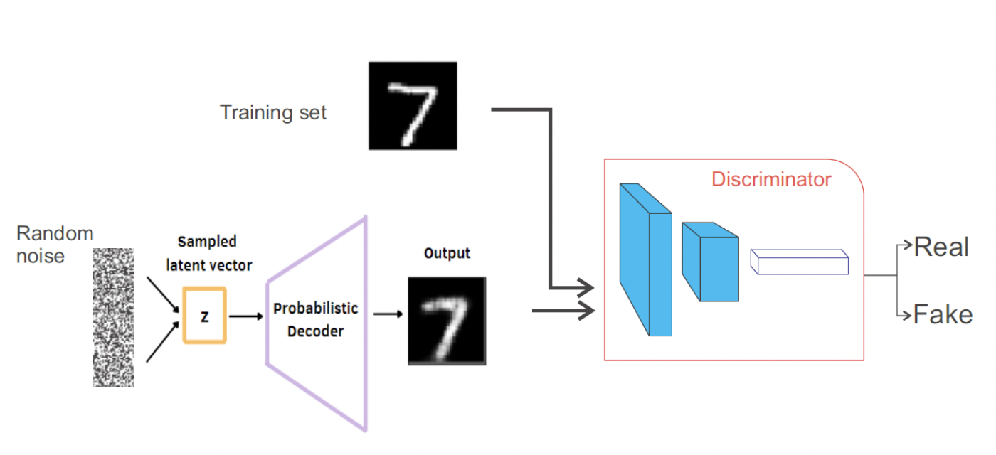

Figure 1 DCGANs with Pre-train Probabilistic Decoder

## Step 1 - VAE

1. **Original architecture**

Originally, we used an autoencoder rather than VAE. Before inputting the images into the encoder, we reshape it and make it into gray images. The input image size is 128*128*1. All layers are Dense layers. However, the reconstructed images are very similar to input ones, but the output from GAN does not make much sense to our human eyes. After taking Professor Kevin Gold’s suggestion, we switched the autoencoder to VAE.

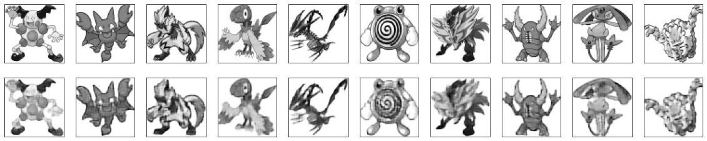

Figure 2 Vanilla Auto-encoder Reconstruct Images

1. **First attempt to improve: use colored image rather than grayscale**

The training outcomes of gray images do not make much sense, so instead of using 64*64*1 as input size, we used 64*64*3 and do not reshape colored images into gray ones. This change turns out to be a wise one, because we can see a vague outline from the outcomes.

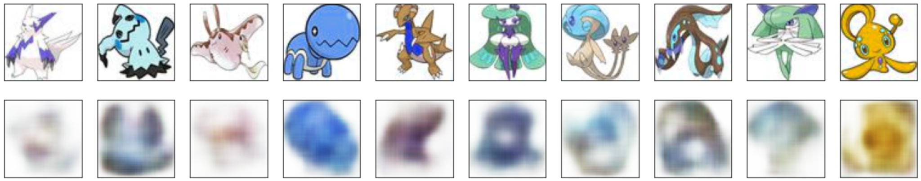

Figure 3 Vanilla VAE Reconstruct Images

1. **Second attempt to improve: data augmentation**

We want to use data augmentation to improve the performance of VAE. First, the pictures have a weird dark background color, which results from rotating photos. We solved it by using svg picture type. Then, because of the rotation of pictures, it ends up having the pokemon not in the center. It looks really weird and not what we want. Therefore, we decided not to use data augmentation in VAE.

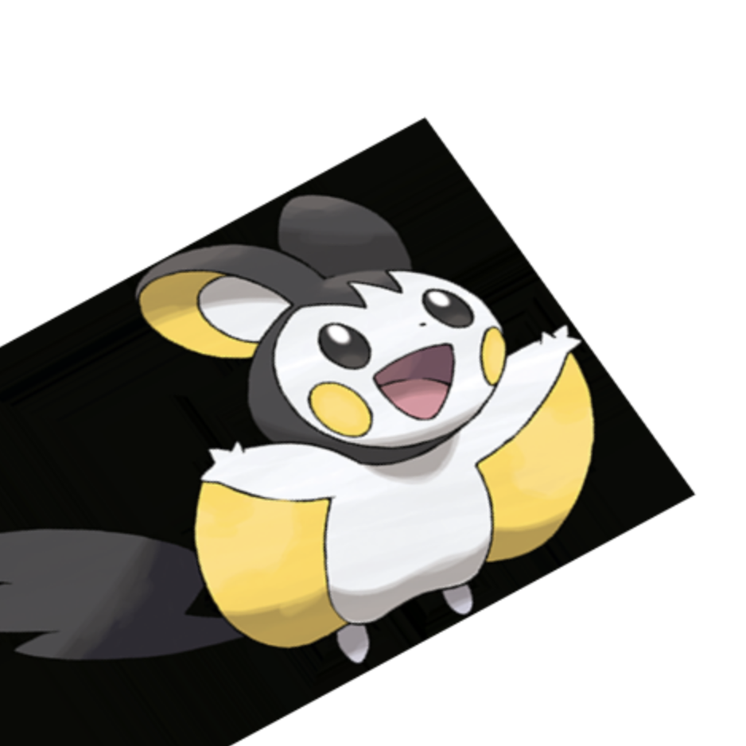 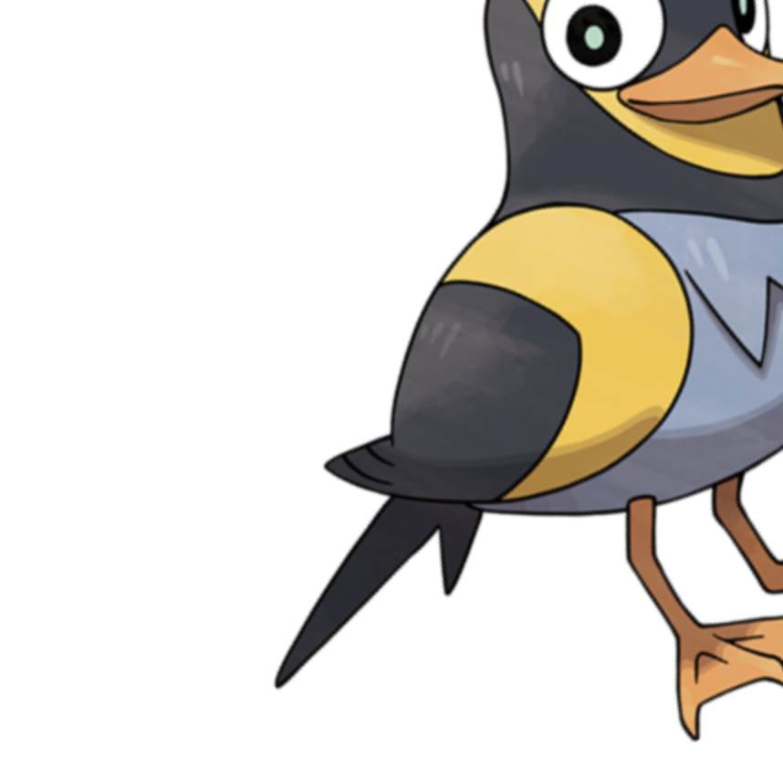

Figure 4 Left: rotated image with dark background color; Right: clean version of rotated image

1. **Third attempt to improve: adding drop out and max pooling layers**

We thought the outcome is not optimal because VAE is overfitting the dataset. Since we only used Conv2D layers in the first version, we added some Dropout layers and/or MaxPooling2D layers. The good thing is: At the beginning, we’ll get rough images containing a round head and half body. As the training goes on, specific features will appear and each image starts to make sense. However, the downside is, using the same number of epochs as before, the reconstructed images are vague.

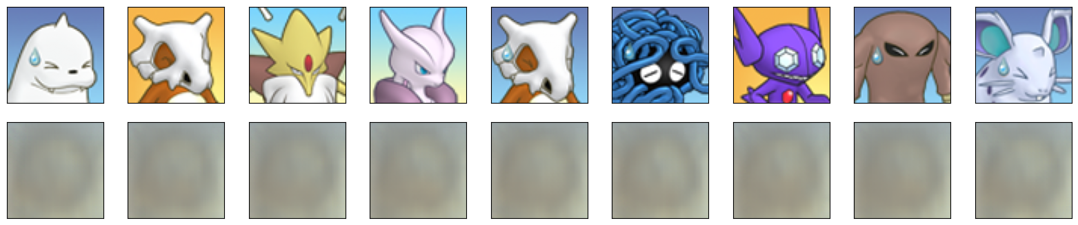

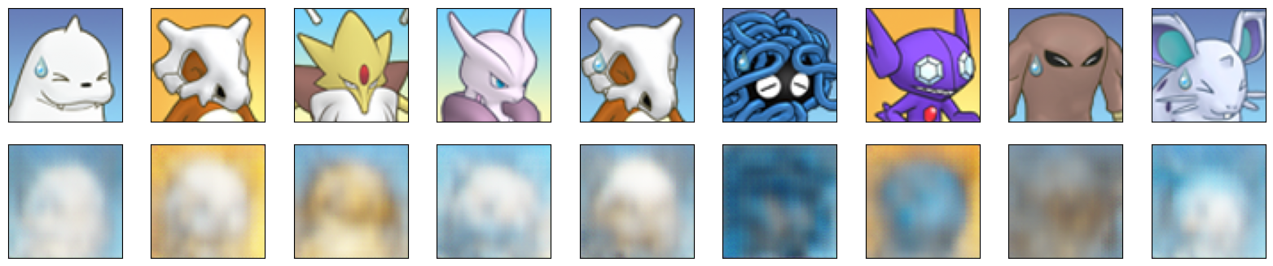

Pictures at the beginning of training - vague half-body and head

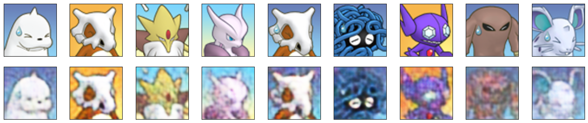

Figure 5 Reconstructed images after 700 epochs

1. **Fourth attempt to improve: change dataset**

We re-analyzed our dataset - it has the most kinds of pokemons, and at least 4 pictures for each type of pokemon, butthe style of these images are too different for VAE to extract common features. Thus, we changed it to a different dataset that also contains most kinds of pokemons but has a more uniform cartoon style and half-body position. The training results turn out to be great.

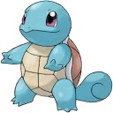 

Figure 6 Left: previous dataset; Right: current dataset

1. **Fifth attempt to improve: latent vectors arithmetic**

Firstly, we trained a VAE using a dataset that only has pikachu and squirtle. After training the VAE, we saved the encoder and decoder as separate models. We found all images of pikachu, used encoders to encode them into sample vectors, and averaged them. Repeated the same process for squirtle and got an average sample vector. Subtract these two average vectors from each other and get a feature vector. When we add a proportion of feature vector to the sample vector of a random image from the dataset, we get a new pokemon with some features from squirtle or from pikachu according to the proportional factor. The formula is: z = z + alpha * z_feature. Then, we input this vector into the decoder model and get the reconstructed image. Here’s the pictures we got from tuning the alpha value.



Figure 7 Image Changing through Different Laten Vector

Picture below is the best outcome, which is a new pokemon that has a squirtle's head, pikachu’s ears, body, and tail.

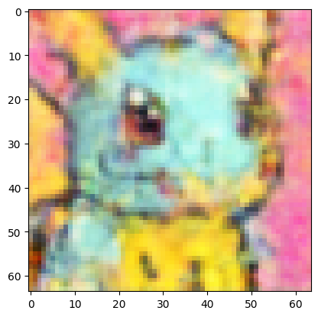

Figure 8 Pokemon Mixed with Pikachu and Squirtle

Secondly, we trained another VAE using a larger dataset that contains most of pokemons. Did similar steps to calculate the feature vector. Here’s some of the results from tuning the alpha value.



Figure 9 Image Changing through Different Laten Vectors for larger dataset

Picture below is the best outcome, which is a genuine new pokemon that does not look like any other pokemon in the dataset.

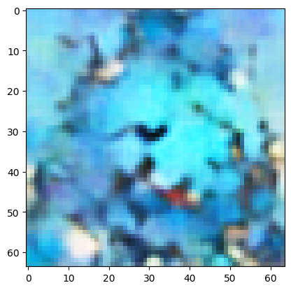

Figure 10 Mixed Pokemon

Overall, We get some good results from using latent vector arithmetic in VAE. However, if we can achieve this by VAE, we don’t really need GAN. It contradicts our original goal, which is to combine VAE and GAN.

1. **Final version of VAE**

The input image size is 64*64*3. In the encoder, we use 4 Conv2D, fully-connected convolutional 2d, layers. The number of output filters goes from 32, 64, 128, to 256. After the last Conv2D layer, we flatten it and add a Dense layer with 512 units, then divide them into two parts - z_mean and z_log_var with 256 units each. 256 is the latent dimension, called LATENT_DIM. Based on the normal distribution with mean and variance, we sample a vector with dimension of 1*256. In the decoder, we feed the sample vector and use Conv2DTranspose layers. The number of output filters goes from 512, 256, 128, 64, to 32. The last layer of decoder uses the sigmoid activation function, and all the other layers use ReLU(the Rectified Linear Unit). We have a function to show training results every 20 epochs. The reconstructed images are very similar to input ones.

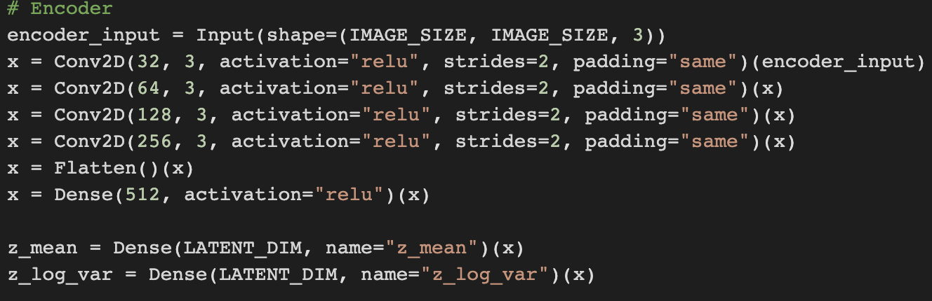

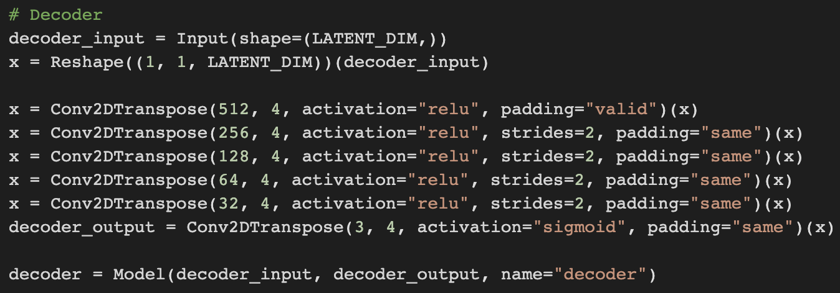

Figure 11 Final version code of encoder and decoder

## Step 2 - GANs

1. **Original Architecture:**

In the vanilla version of GANs, we used 3 Conv1D layers and 1 max pooling layer to generate the z value from the noise and pass the z value to the decoder. In this step, we pass in 100 dimensions of noisy vectors and gradually convert them to two 256-dimensional vectors, as shown in Figure 12.

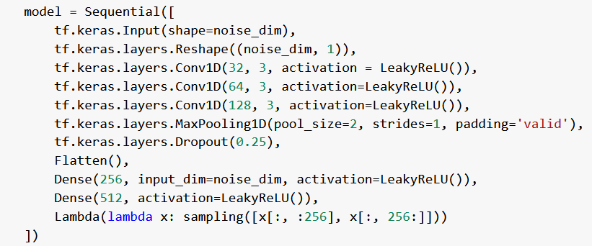

Figure 12 Part of the architecture for vanilla GANs

After we have mean and variance vectors, we sample them to z value and pass the z value into the pre-train decoder. We unfroze the last 3 layers of the decoder since we hope the decoder can also learn something during the GANs’ training process.

We also have generally high learning rates 5e-3 for both G and D with vanilla loss function as shown in Figure 13, without any dropout and batch normalization in D and G.

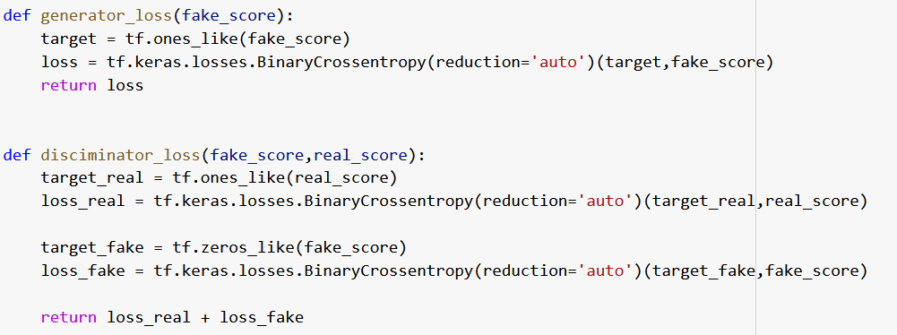

Figure 13 Loss function for vanilla GANs

For the training step, for each batch of images, we train D and G simultaneously and update their weights, as shown in Figure 14.

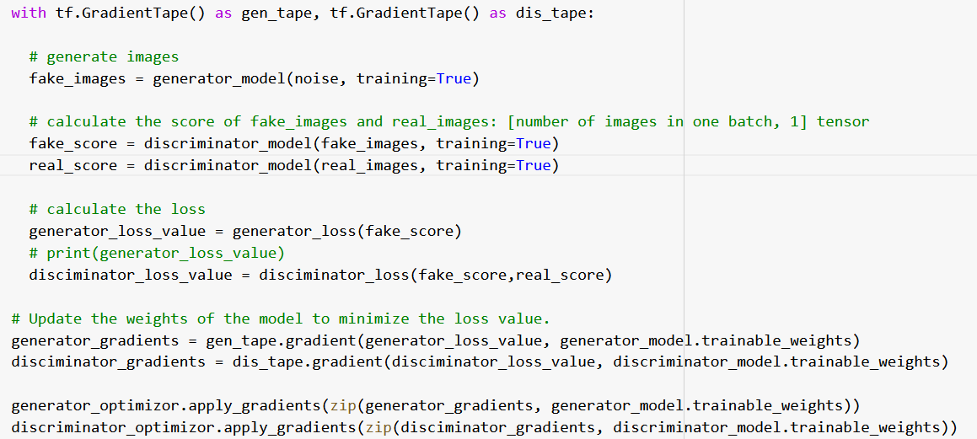

Figure 14 Parts of training steps for vanilla GANs

Obviously, the training results are not great, as shown in Figure 15.

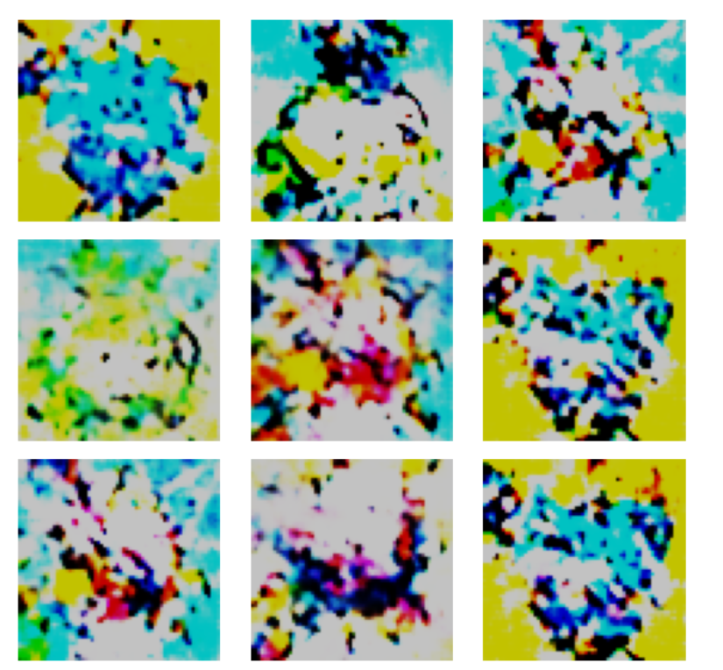

Figure 15 results for vanilla GANs

1. **First improvement:**

By reviewing the loss and image quality from the vanilla version, we observe that G and D’s loss value is highly unstable. The decoder generally loses its advantage from pre-train since parts of it are trainable.

As a result, we froze all layers in the decoder and changed the D’s architecture. As shown in Figure 16, we introduce CNN layer, batch normalization, and LeakyRelu into D in order to stabilize the training and reduce the number of parameters. This version of D works pretty well we don’t change it after.

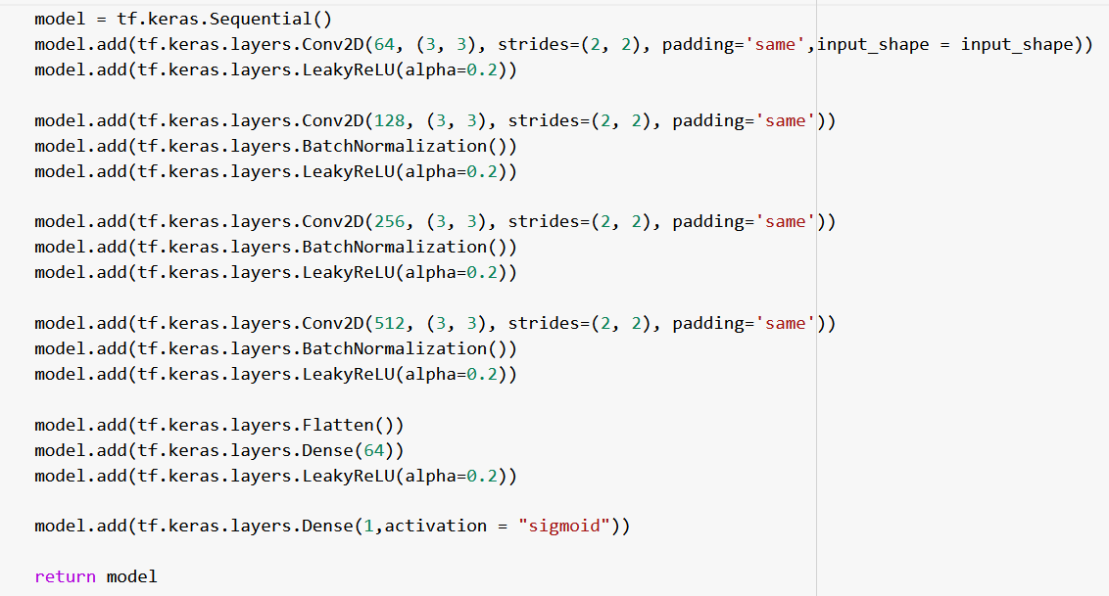

Figure 16 Final version of Discriminator

Also,we change our loss function to Wasserstein Loss as shown in Figure 17, and re-design the training architecture, as shown in Figure 18. Also, we change our optimization function from Adam to RMSprop.

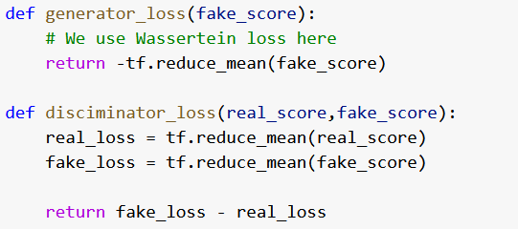

Figure 17 Wasserstein Loss function

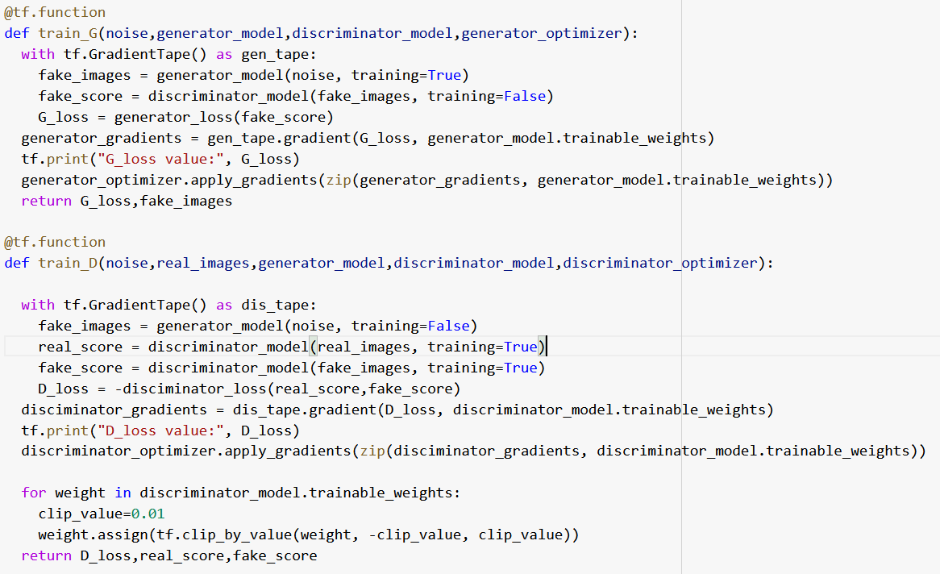



Figure 18 WGANs training architecture

In WGANs, we separate the training of G and D, we train D four times and G one time according to WGANs pseudocode. During the Training of G, we froze the weights in D, and vice versa. This idea improves the stability of training a lot.

Also, we implement the learning rate schedules and reduce the initial learning rate, as shown in Figure 19.

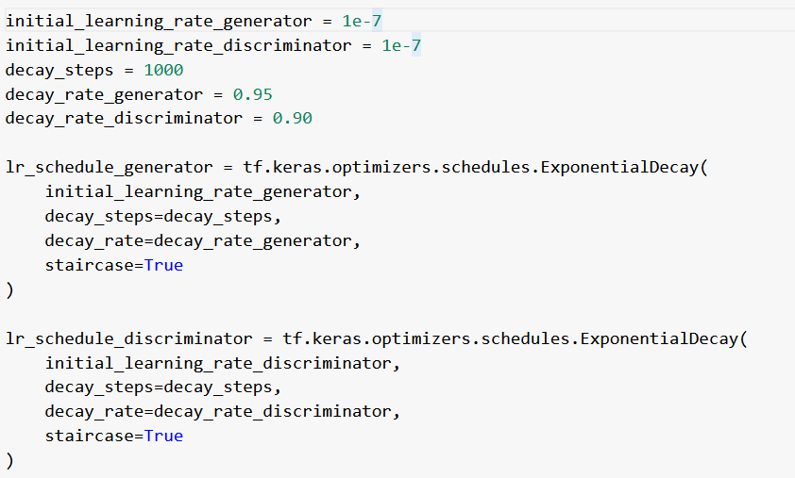

Figure 19 Learning rate schedule

After the previous implementation, the loss value, and image quality improved significantly, but still did not reach our expectations, as shown in Figure 20.

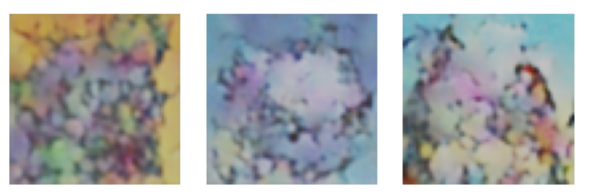

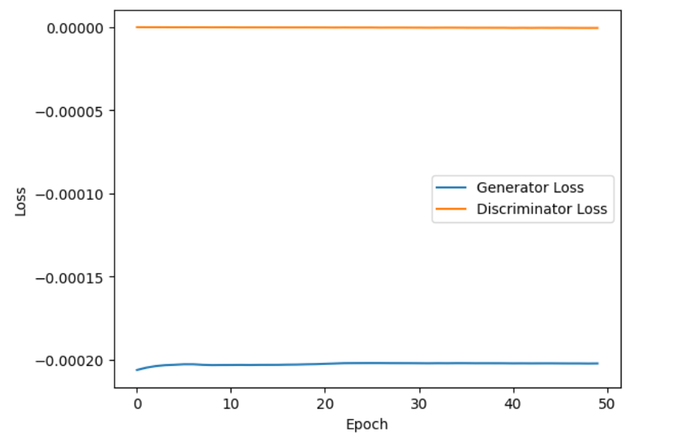

Figure 20 WGANs results

1. **Second improvement (Final Version):**

After tunning WGANs, we realized that WGANs may not be suitable for our task, since we can’t solve the gradient vanishes problem and the images’ quality doesn’t improve during training. So we change our loss function back to the original and change the loss function from RMSprop to Adam.

Also, we remove the learning rate schedule since it is hard to tune, but we remain the small learning rate at 1e-5.

At this time, we spend more time on the exploration of the Variational autoencoder and we realize we can ask G to generate the z value directly, instead of sampling. As a result, we reduce the latent vector’s dimension from 256 to 128 since the G can pick up points in hidden space easier if the dimension is lower. As shown in Figure 11, we remove all CNN layers in Generator and add batch normalization to improve image quality and drop out layers to avoid the mode collapse problem (all neural work together to generate the same image whatever the noise vector is) and add leakyRelu and tanh as activation function.

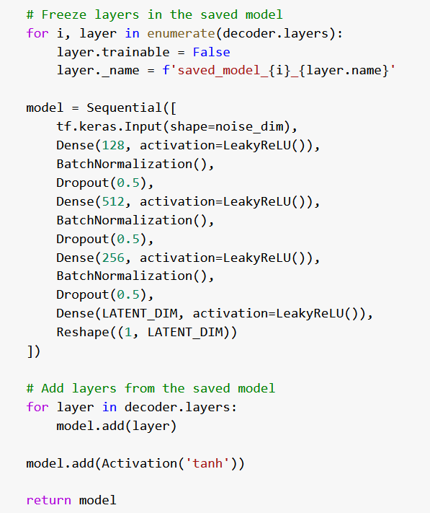

Figure 21 Final version of Generator’s architecture

Inspiring from WGNs, our team modifies the architecture of training steps to give the generator more chance for training, as shown in Figure 22.

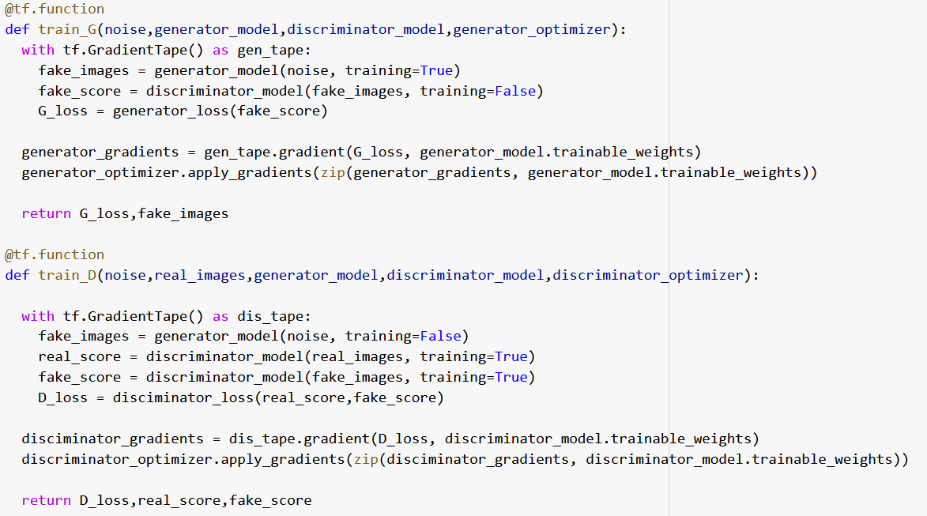

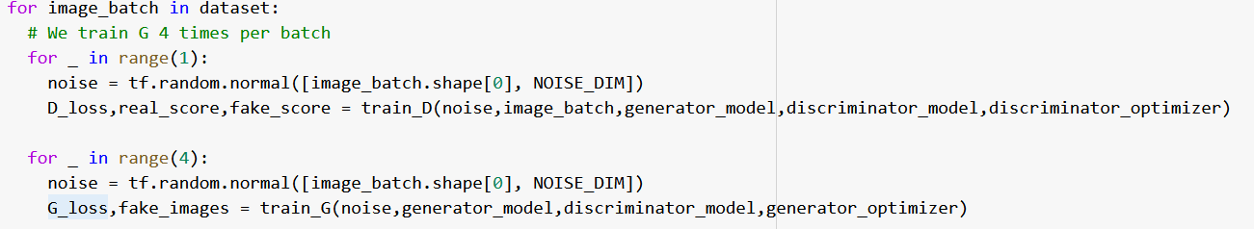

Figure 22 Final version of training architecture

Finally, we get decent results and stable loss from GANs (explain more in the results part) and we can test our models.

Our team tests our models in two different datasets: the Pokemon dataset (source) and the Animate Girls Face dataset (source), both with 64 * 64 pixels. We first examine the quality of reconstruction images of two data types separately and save two different decoders; second, we will use decoders to generate images through GANs and compare the fake images’ quality; third, we contact two datasets together and train a new VAE to compare the different of latent space; fourth, using new decoder, we only feed one dataset (Animate face for example) to GANs and check the output of G (we hope we can get result that G can generate face with some Pokemon features).

# Results

Reconstructing results are acceptable for both Pokemon and Animate faces, shown in Figure 23.

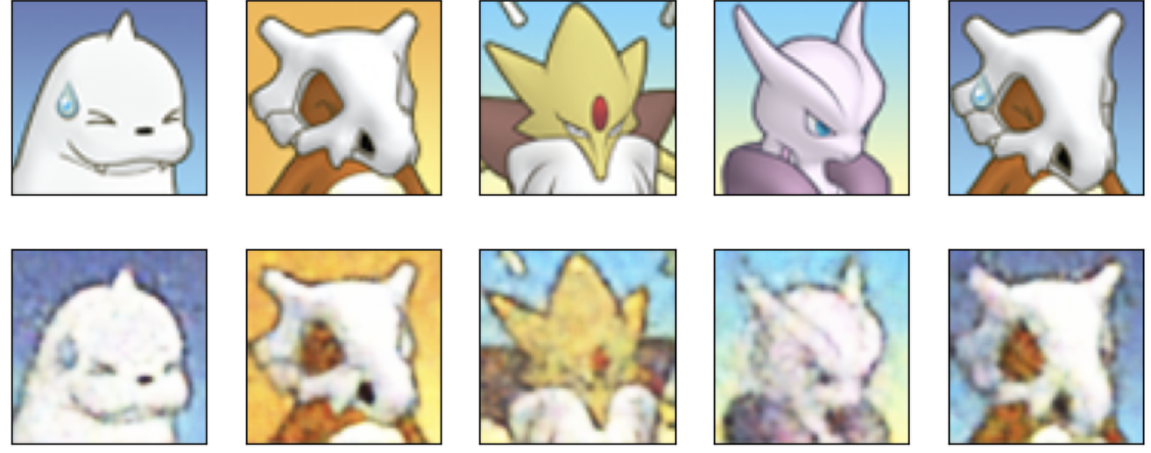

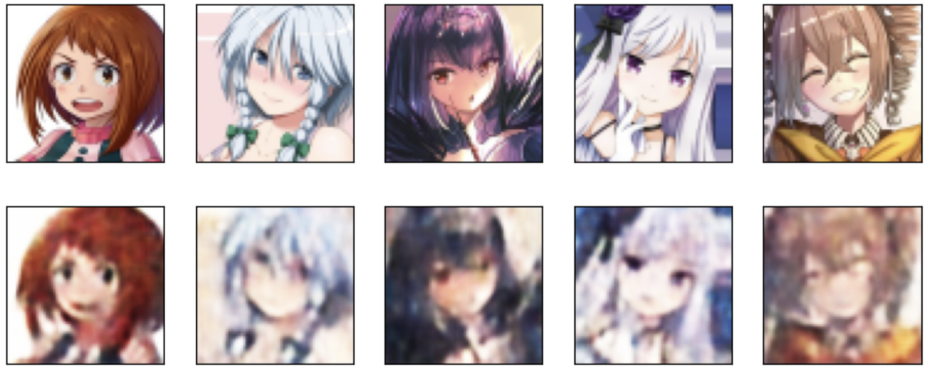

Figure 23 Reconstruct Pokemon and Animate Face (Upper: Pokemon; Bottom: Animate Face)

However, as shown in Figure 24, latent vector distribution differs across the two datasets. z value of the Pokemon dataset is more sparse in latent space, which means G may need more effort to generate a similar z value comparing generate an animate face.

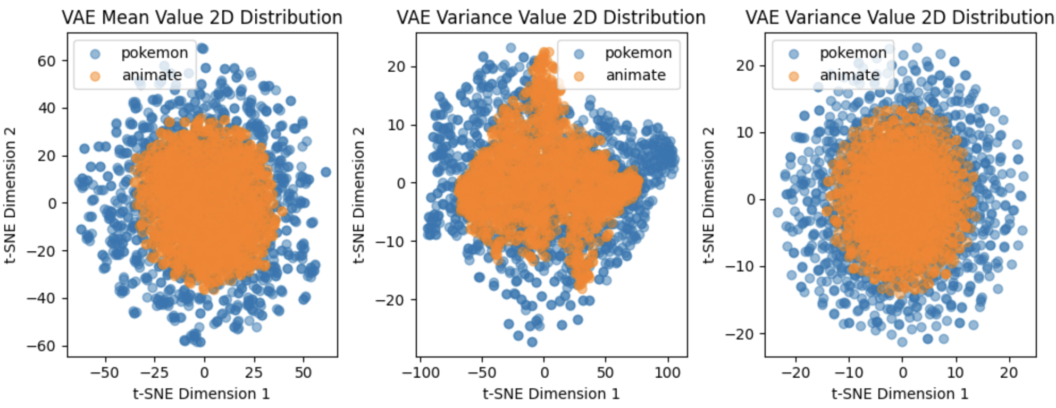

Figure 24 Comparing in Latent space of Pokemon and Animate Face (Upper: Pokemon; Bottom: Animate Face)

Figure 25 shows the images generated by G for Pokemon and Animate Face through random vectors. It is obvious Animate face has more initial advantages due to its narrow latent space.

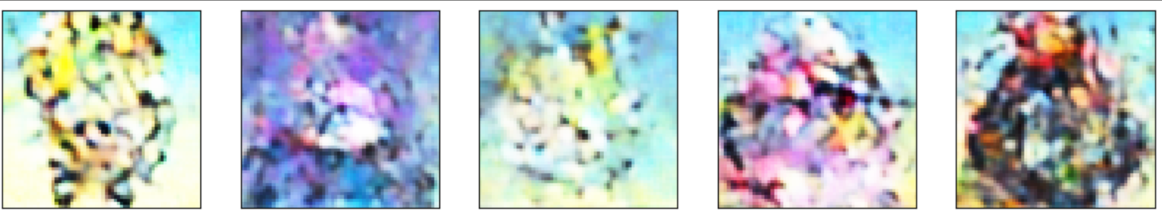

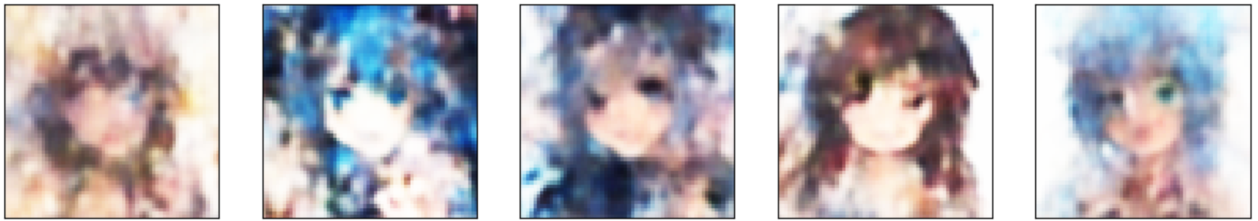

Figure 25 Random Generation of Pokemon and Animate Face (Upper: Pokemon; Bottom: Animate Face)

Figure 26 shows GANs’ training error. By tuning the hyperparameter such as learning rate, and epochs, and modifying the training process (in one epoch, we froze D and let G train multiple times), even though D is stronger than G, G’s loss is stable after a couple of epochs.

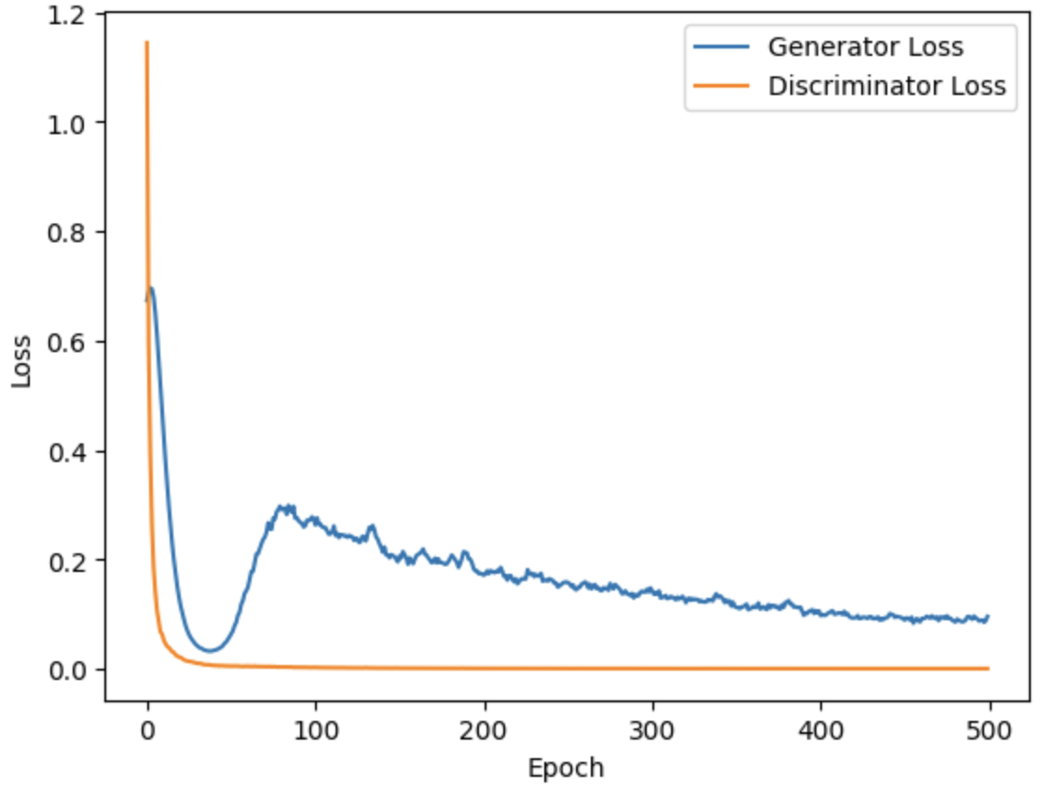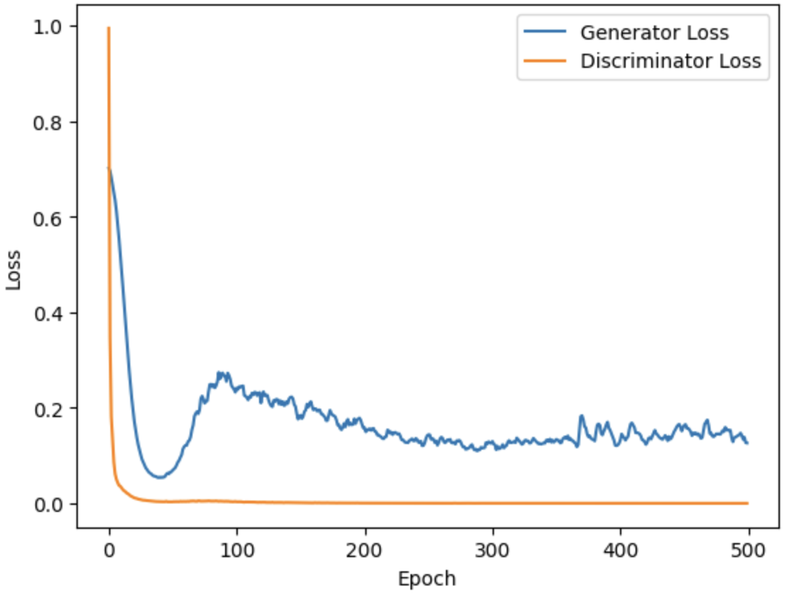

Figure 26 GANs Training Loss(Left: Pokemon; Right: Animate Face)

Figure 27 are images generated (left: VAE train by Pokemom data, GANs also train by Pokemom data; right: VAE train by Animate data, GANs also train by Animate data. Model architectures and hyperparameters are the same).

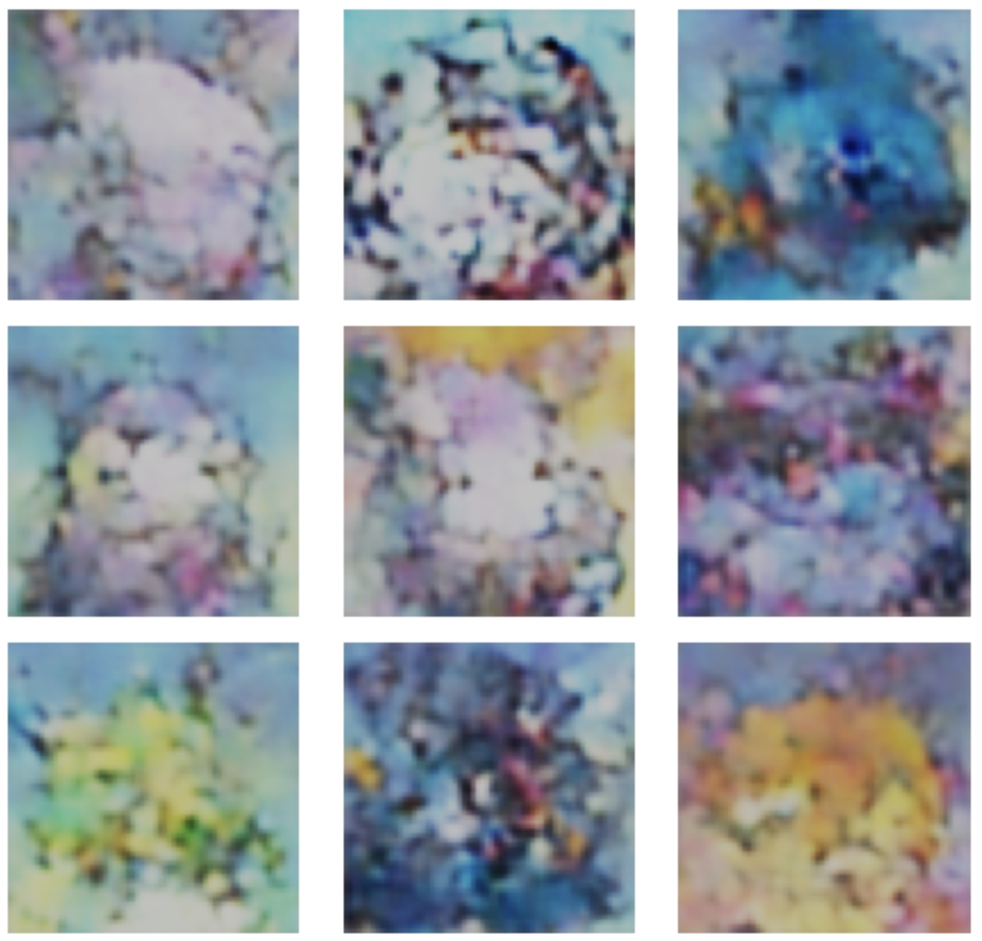 **+** 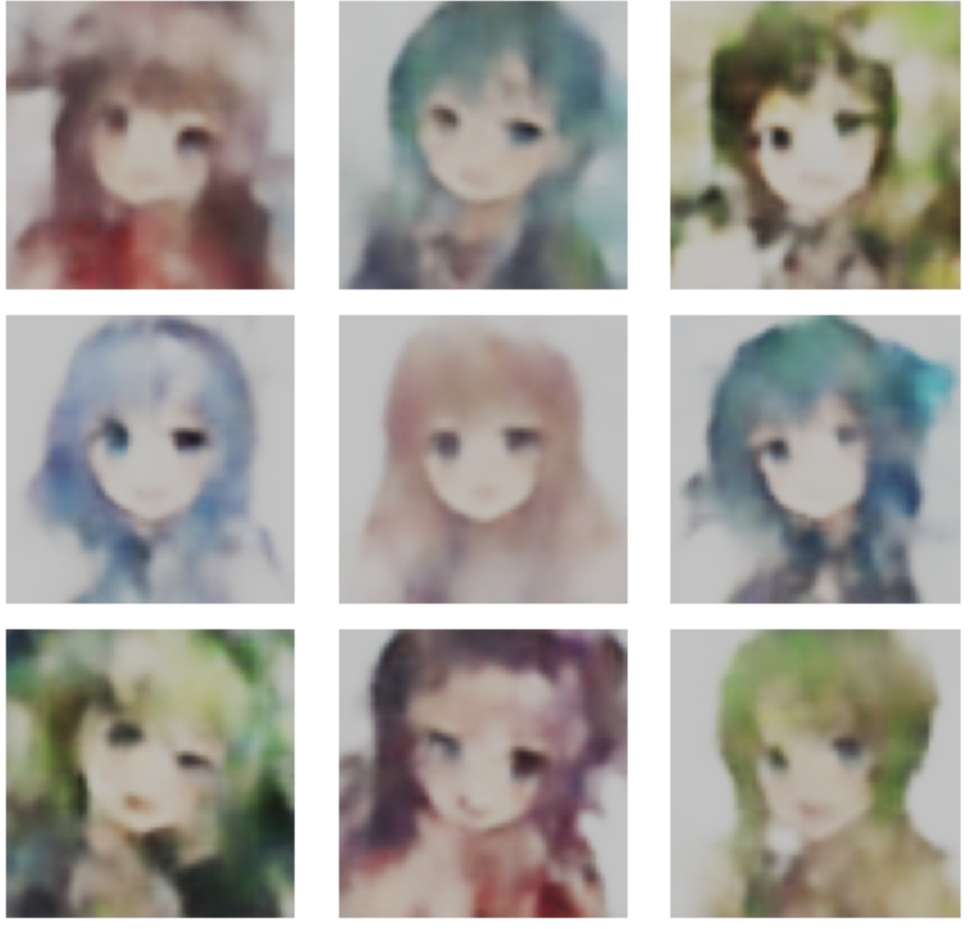

Figure 27 Generate Image (Left: Pure Pokemon; Right: Pure Animate Face)

**=**

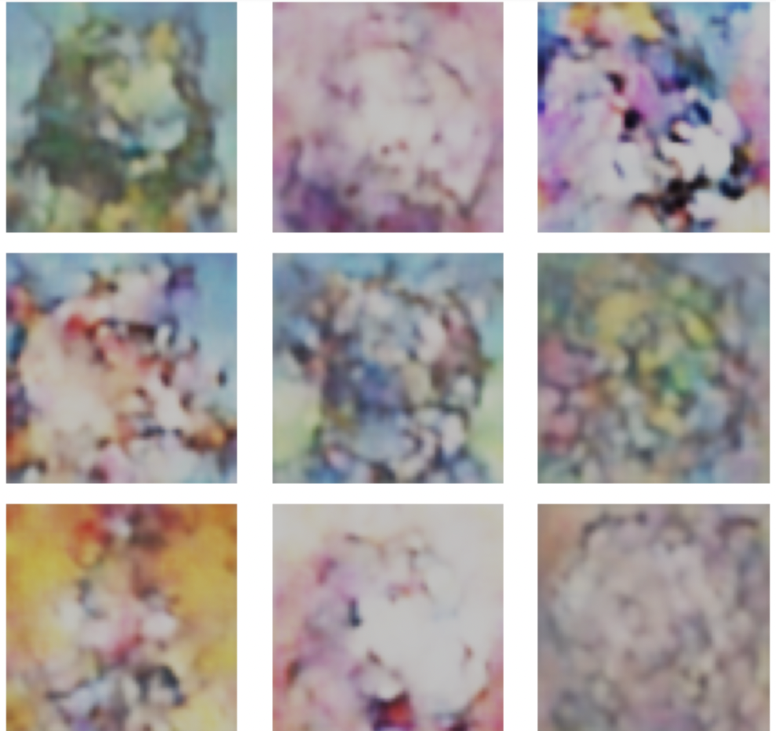**OR**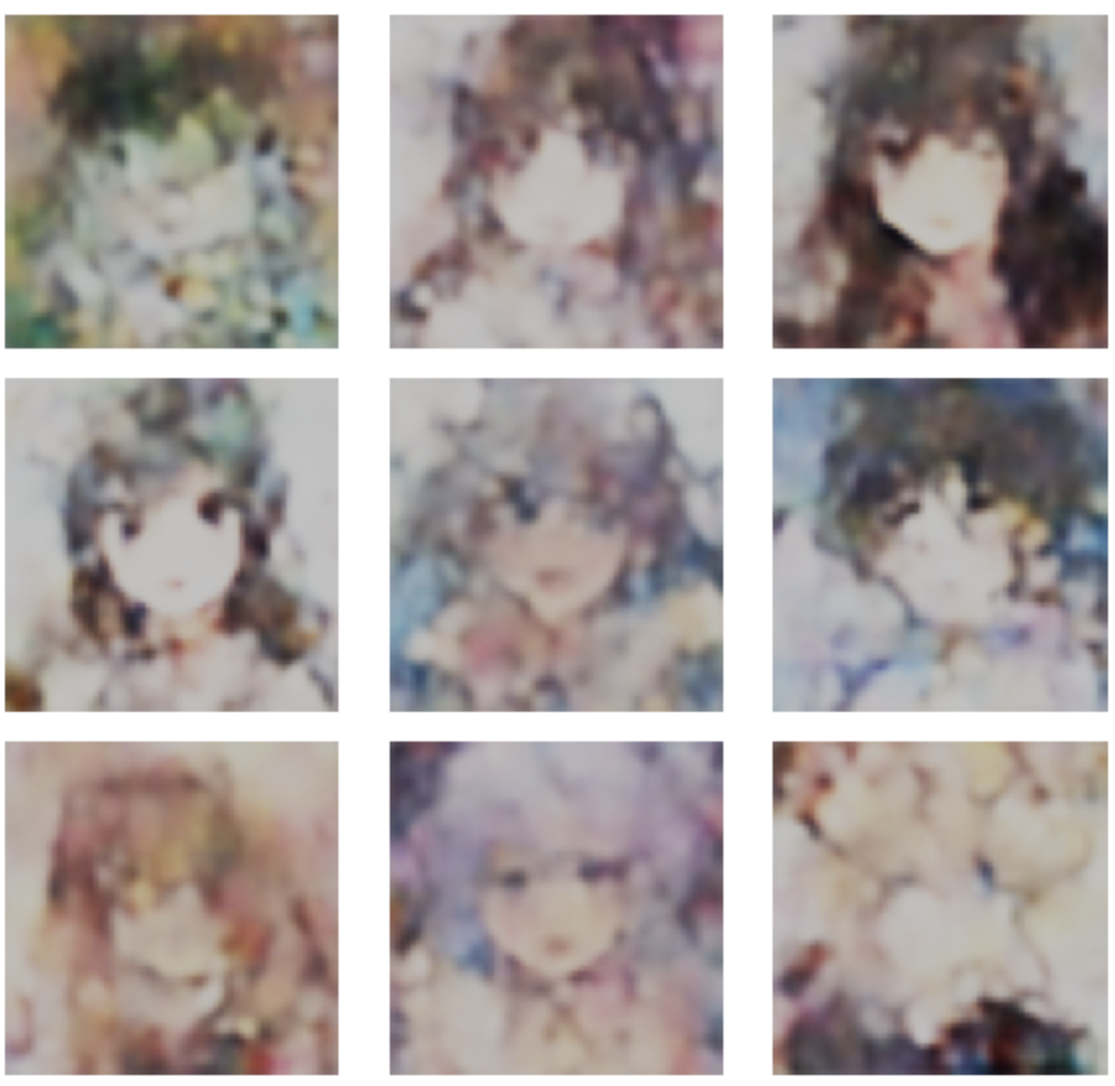

Figure 28 Generate Image (Left: contact VAE + Pokemon GANs; Right: contact VAE + human GANs)

As discussed before, the data distribution in latent space has a significant impact on generated data. Pokemon data have more complex features which require more capacity for a generator and are more difficult to train. As a result, Generated animated faces have better quality in general.

Back to Figure 24, when animate data and Pokemon data combine together and train a single on VAE, two different types of data distribute differently in the latent space. When we feed only one type of data to GANs, such as Pokemon, the Generator has the ability to only pick blue data points in Figure 24, and vice versa. As shown in Figure 28, most left-generated images are Pokemon with some human features since the data we fit into GANs are Pokemon. Like the right side generated images, most images are faces since we feel animate girls' faces to the GANs. Figure 29 and Figure 30 show some detailed illustrations.

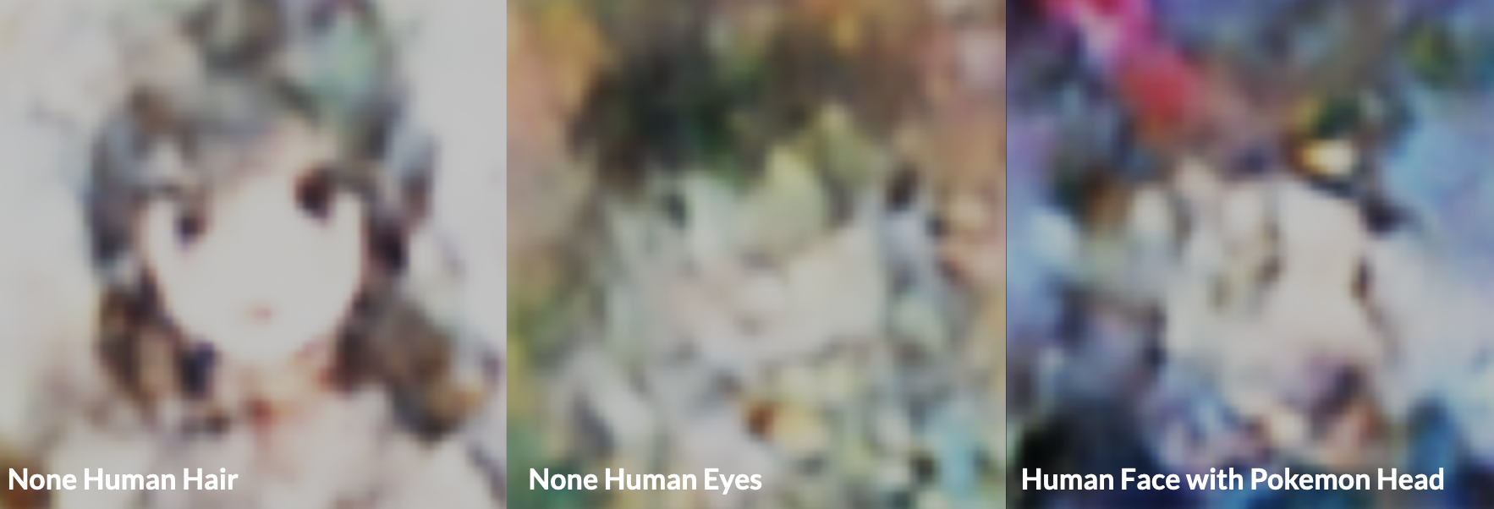

Figure 29 Generate Image (VAE: Pokemon + Animate Face; GANs: Animate Face)

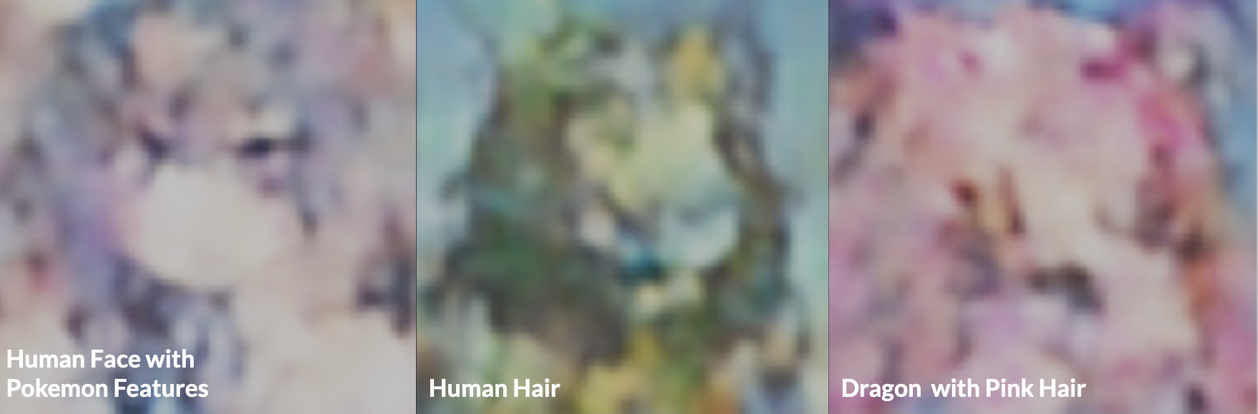

Figure 30 Generate Image (VAE: Pokemon + Animate Face; GANs: Pokemon)

# Conclusion

To conclude, we found that it is difficult for VAE and GAN to learn features of Pokemon that are general enough that they can randomly generate new Pokemons. This is because existing Pokemons are too different from each other. Choosing a more consistent dataset, images of Pokemons with same poses or similar features, can help to improve the quality of the generated images. Another potential solution is to include more Pokemon images in the training dataset, but we have included all current existing Pokemons in our dataset, so people have to wait until the future generations of Pokemon are released to see if this solution works.

Moreover, we found that adding another more consistent dataset of anime faces helps to improve our results. We think that this probably works for image generation machine learning topics too. If the training dataset is too scattered in the latent space, it is a good idea to include another dataset that is very concentrated in the latent space in the training dataset. The quality of generated images will improve with the tradeoff that the new images are contanning features from the new dataset.

In summary, our research demonstrates the potential of advanced machine-learning techniques in augmenting the process of creating new Pokemon. By leveraging the power of GANs and combining them with VAE, we were able to generate new Fakemons that showcase the potential of this approach. Future work can continue to build on this approach, paving the way for more exciting and unique Fakemons to be created in the future.